7 de febrero de 2019
Jhon MANUEL Angulo MONCADA
MCA SYSTEM S.A.S.
Barranquilla Colombia
HORUS CORTINA CONFIGURATION
curtain control

Description:

Horus curtain application allows the user to control one or more curtains using a switch as trigger of the system, sending the order of open, close and stop the curtain.

Setting up steps:

1. Identify the curtain and switch devices to use.

Go to device, then to settings and advance settings, an ID will be shown, in this example, the curtain id is 133 and switch button is 33.

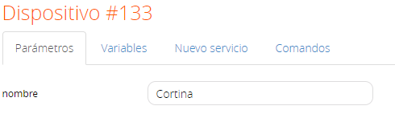
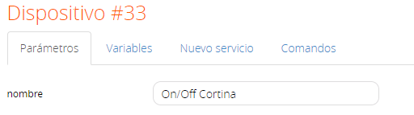

2. Set the devices ID’s in the application variables.

Get into Horus Cortina application, then enter in settings, get into advance settings and finally variables.

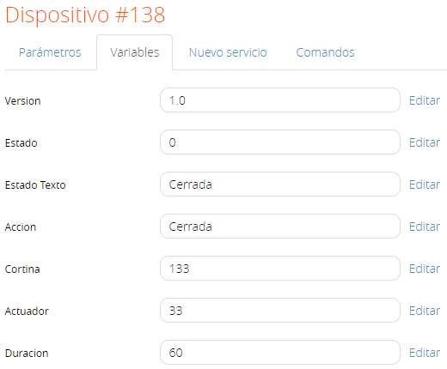

Here you must insert the curtain id and button id, stablish the time that the curtain takes to open and close completely. The time must be stablished on seconds, by default the time is set on 60 seconds (1 minute).
Is recommended calculate and adjust the time depending on your curtain.

3. Finished

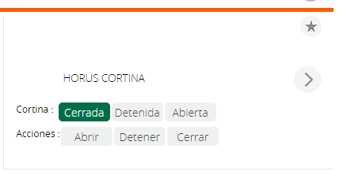

4. Function:

- Open the curtain.
- Close the curtain.
- Stop the curtain.

5. Operation:

When the switch is turned on, the curtain will open or close depending on its current state. If the curtain is open, once the user presses the switch, the curtain will start to close and when the time runs out, the switch will turn off.
If the curtain is close, once the user presses the switch, the curtain state will change to open, once the time runs out, the switch will turn off.
To stop the curtain, the switch must be pressed, this command only works during execution time of open or close of the curtain.

